Nepal College of Information Technology
Assessment
Fall 2010
Program: ELX/IT/CE Time: 3 hrs
Semester: Fall (III) FM: 100
Subject: Engineering Math-III PM: 50
Candidates are required to give their answers in their own words as far as practicable.
The figures in the margin indicate full marks.
Attempt all the questions:
1 a) Show that
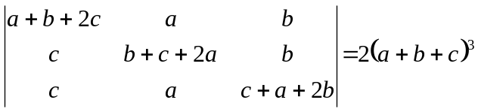 [8]
b) Let A and B be two matrices of specified order, then show that (AB)⁻¹ =B⁻¹ A⁻¹ , where A and B are non-singular matrix: [7]
OR
Solve by using Gauss elimination method:
4x-8y+3z=16
-x+2y-5z=-21
3x-6y+z=7

2. a) Define rank of a matrix. Find the rank of
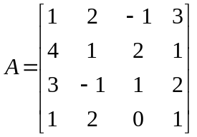 [7]
b) Find eigen value and eigen vector of a matrix
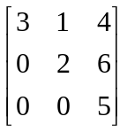 [8]

3. a) Prove that the necessary condition for the convergence of an infinite series 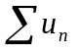 is 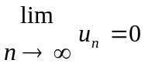, but this is not sufficient. [7]
b) Test the convergent or divergent of the series: [4*2=8]
i) 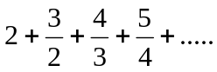
ii) 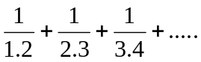

4. a) Define periodic function. Find the period of
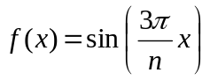 [5]
b) Define even and odd function. Check even, odd or neither even nor odd of the function
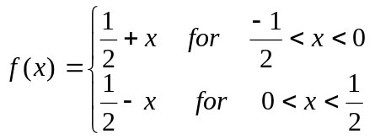 [5]
c) Find a unit vector normal to the surface
x²y + 2xz = 4 at (2, -2, 3) [5]

5. a) In what direction from (3, 1, -2) is the directional derivative of f= x² y² z⁴ maximum and what is its magnitude? [7]
b) Show that the value under the integral
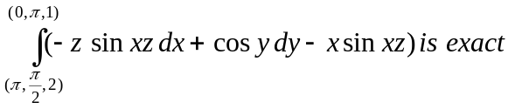and evaluate the integral. [8]

6. a) State Green's theorem in plane. Using this theorem, evaluate
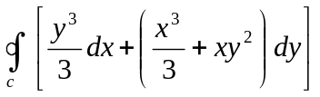 Where c is the boundary of the region between y = x² and y= x, 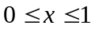 (Counter clockwise) [8]
OR
Evaluate 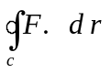 Where
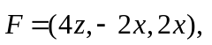c is the circle x²+y²=1, z=y+1
b) Find 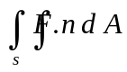 where
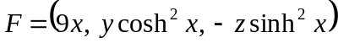, s is the ellipsoid
4x²+y²+9z²=36. [7]

7. Attempt all [5*2=10
i) Find inverse of a matrix 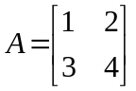.
ii) Check the transformation 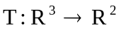 defined by T(x, y, z) = 9x+y+z, 0) is linear or not.
iii) Define convergent and divergent series.
iv) Show that the vector
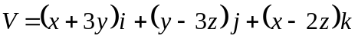 is solenoidal.
v) If 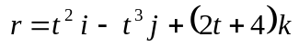
Find 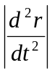 at t=0.

